

**Name: Khizar Ali**

**Roll No: 22P-9269**

**Subject: Programing Fundamentals LAB**

**Submitted to:**

**Problem: 1**

**Write a Program in C that takes feet from user convert it into Inches.**

**1 Feet = 12 inches**

**#include<stdio.h>**

**int main()**

**{**

**int feet , inches ;**

**printf("Enter feets \n");**

**scanf("%d",&feet);**

**inches=feet*12;**

**printf(" %d feets = %d inches ", feet,inches);**

**return 0;**

**}**

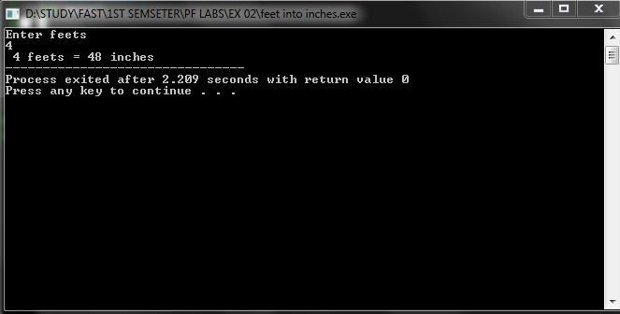

**Problem: 2**

**Write a C program that takes quantity in pounds from user and convert it into grams.**

**1 pound = 453.592 gram**

**#include<stdio.h>**

**int main()**

**{**

**float pound , gram;**

**printf("Enter pounds \n");**

**scanf("%f",&pound);**

**gram=453.592*pound;**

**printf("%.2f pound = %.2f grams \n",pound, gram);**

**return 0;**

**}**

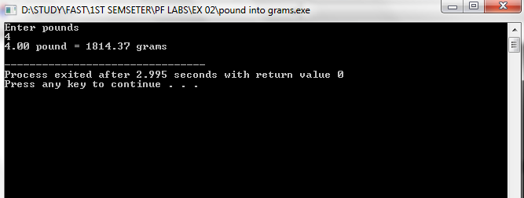

Problem: 3

Write a C program to compute (a + b)3 where the value of a and b will be

provided by the user.

#include<stdio.h>

int main()

{

int a, b , ans;

printf("Enter Value of a \n");

scanf("%d",&a);

printf("Enter Value of b \n");

scanf("%d",&b);

ans=a*a*a + b*b*b + 3*a*b*(a + b);

printf("(%d + %d)^3 = %d",a , b ,ans);

return 0;

}

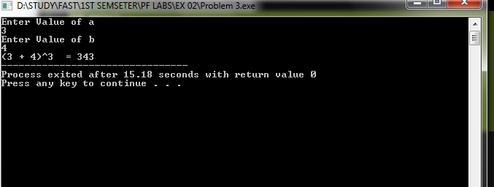

**Problem: 4**

**Write a program that takes seconds from the user and displays the time in Hours, minutes and seconds’ format.**

**E.g. if the user enters 3700, the output of the program should be**

**1 Hour 1 minutes and 40 seconds.**

**#include<stdio.h>**

**int main()**

**{**

**int seconds, minutes, hour ,sec;**

**printf("Enter time in seconds \n");**

**scanf("%d",&seconds);**

**hour= seconds/3600;**

**minutes=(seconds-(3600*hour))/60;**

**sec=(seconds-(hour*3600)-(minutes*60));**

**printf("%d hours %d minutes %d seconds \n", hour , minutes , sec );**

**return 0;**

**}**

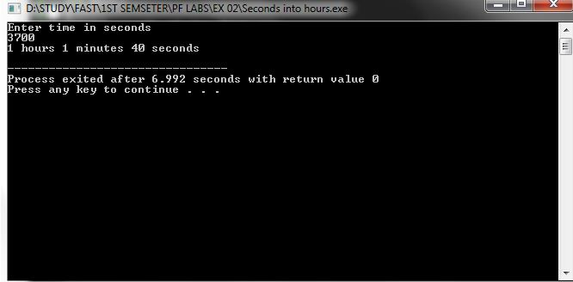

**Problem 5:**

**Write a program that takes seconds from the user and displays the time in Days, Hours,**

**minutes and seconds’ format.**

**#include<stdio.h>**

**int main()**

**{**

**int seconds, minutes, hour ,sec, day ;**

**printf("Enter time in seconds \n");**

**scanf("%d",&seconds);**

**day = seconds/(24*60*60);**

**hour= (seconds-day*86400)/3600;**

**minutes=(seconds- hour * 3600 - day*86400)/60;**

**sec=(seconds-day*86400-(hour*3600)-(minutes*60));**

**printf("%d days %d hours %d minutes %d seconds \n",day, hour , minutes , sec );**

**return 0;**

**}**

